BOROUGH OF LIGONIER
TOWN HALL
LIGONIER PENNSYLVANIA LS
Application for Driveway Curb Cut in Ligonier Borough
Permit Number: CC-
Tax Map # 16- -0- Zoning District
Fee payable to Borough of Ligonier $27.50
Owner(s) of Property:
Address of Owner:
Phone Number of Owner:
1. Applicant:
(Address) (Phone) if not Property Owner
2. State Highway Permit Required? Yes No
3 Type of curb to be cut? Concrete Asphalt |  | Other

- Type of driveway to be installed?
- Type of approach to be installed?
- Width of cut proposed?
- Distance from edge of proposed cut to:
Nearest Power (utility) Pole
Nearest Water Hydrant
Nearest Property Line
Nearest Street (alley) Intersection
Nearest Tree in Tree Lawn
Nearest Catch Basin

8. Distance from the centerline of proposed cut to centerline of nearest neighboring driveway:
- Distance between curb and sidewalk at proposed position to be cut:
- Height of sidewalk above street level:
- Proposed methods of making cut:
- Cut proposed for EXISTING or NEW Driveway? (Cross one out)
- Do other curb cuts and/or driveways enter this property? Yes No
- Is there rear access to this property? Yes No
- Will this curb cut obligate property owner to move a hydrant, power pole, tree, catch basin, or other? Yes No
I hereby acknowledge that I have read this application and that the above is correct and agree to comply with all Borough Ordinances and Commonwealth of Pennsylvania Laws regulating this construction.
Signed: Date:
(Applicant)
Application (approved) (rejected —see attached report)
Signed: Date:
(Issuing Official)
Fee Paid $ Date:
Received by:

CLASS "A" CONCRETE
VARIES
SECTION

IR
a . . 0 . . ... . . 00
-00 0
. 0
#57 AGGR. BASE
4" OR MATCH EXISTING
1117--¹--⁻-:11
=111 -
.... 0 0000 0 0 0 0 0 0 0 0
* 0 00 00 ⁰⁰⁰⁰ ⁰ * 0
6"x6"-W2.0xW2.0 W.W.F PLACE IN MIDDLE
OF SLAB
N.T.S.
NOTES: 1. FOR LONG LENGTHS OF SIDEWALKS, EXPANSION JOINTS (1/2" WIDTH, FULL DEPTH, WITH SEALANT) SHALL BE CONSTRUCTED EVERY 12 FEET AND CONTRACTION JOINTS we WIDTH, 1" DEEP WITH SEALANT) EVERY 4 FEET CENTER TO CENTER.
TYPICAL DETAILS
CONCRETE WALKWAY
THE EADS GROUP INC. STD. 30
-

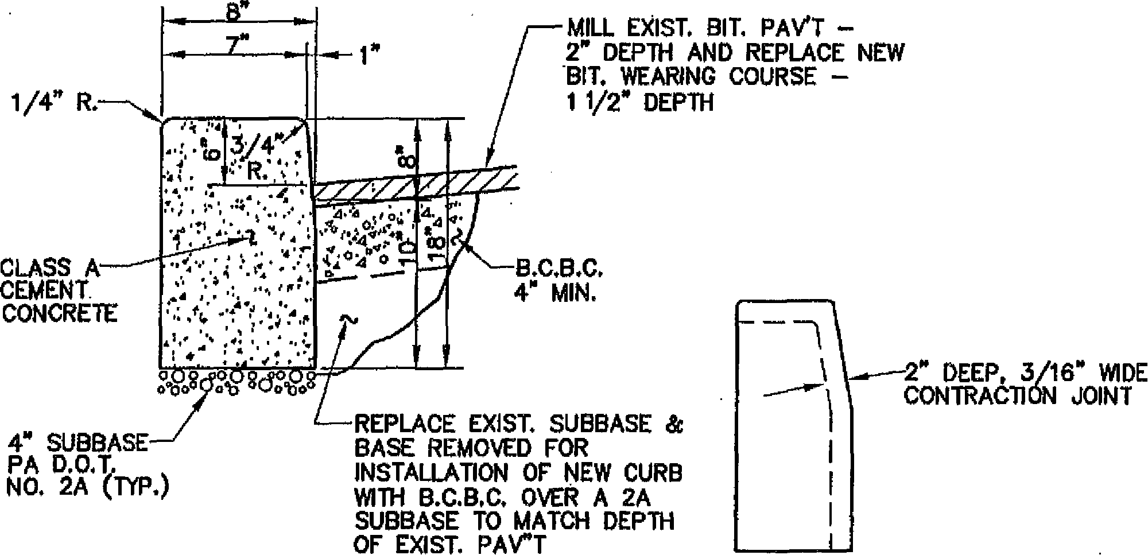
B.C.B.C. 4" MIN.
REPLACE EXIST. SUBBASE & BASE REMOVED FOR INSTALLATION OF NEW CURB WITH B.C.B.C. OVER A 2A SUBBASE TO MATCH DEPTH OF EXIST. PArT
1/4" R.
MILL EXIST. BIT. PAVT
2" DEPTH AND REPLACE NEW
BIT. WEARING COURSE — 1 1/2" DEPTH
CLASS A CEMENT
CONCRETE
a gd:
4" SUBBASE PA D.O.T.
NO. 2A (TP.)
2. DEEP, 3/16" WIDE
CONTRACTION JOINT
STANDARD CURB DETAIL  N.T.S. | CURB JOINT DETAIL  N.T.S.
₁₀0₀04⁰W5,0V$
JO\
CONTRACTION JOINT
^{411k}
Cv 0
PLAIN CEMENT CONCRETE CURB SECTION
N.T.S.
TYPICAL DETAILS
CONCRETE CURB DETAILS

THE ENDS GROUP INC.
STD. 64

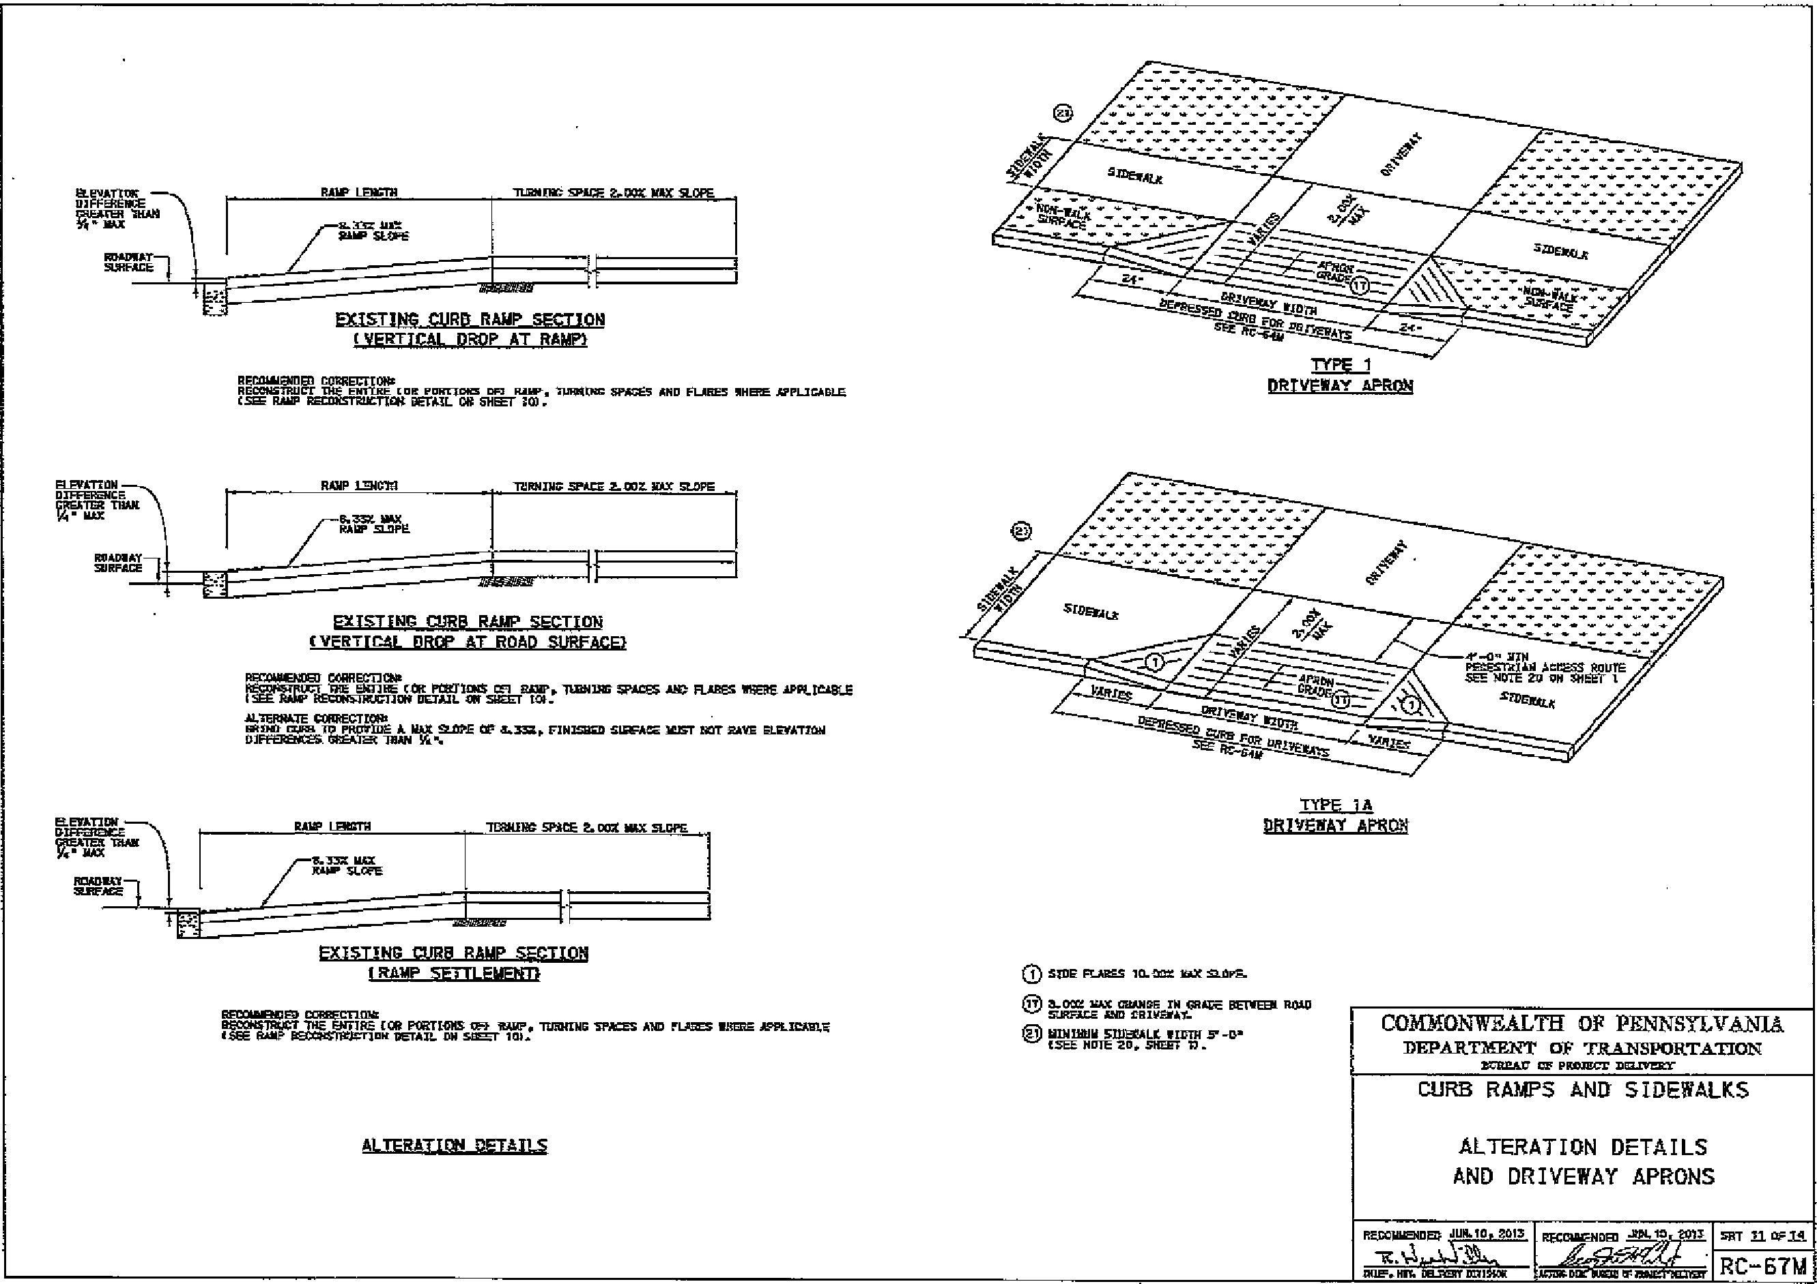
ALTERATION DETAILS
AND DRIVEWAY APRONS
ALTERNIIDN DETAILS
EXISTIND CURD RAMP SECTION
(VERTICAL DROP AT RAMP?
TYPE I
DRIVEWAY Amica4
0
REcaismEn 002RECttals
RECONSTRUCT tHE ENTIRE EON PONTIO. Nur, UMW= spAsEs AND FLARE! mom _{m}um.=Am_{m}o
IMM RAMP ON DECAL OM SHEET .
/ILEUMS OJEFENENUE vELEATEN SHAN
JAUI
RAW LE103/1 TENNI= SEACE 2.203 lakr mows
ELEVATION OIFFSIONCE OUTER 111ML K• MIX
READ:RAY
SURFACE
EXISTING CURB RAMP SECTION
RR(P AT ROAD SURFACS)
RECOANENEED CORNEVECA*
rEco/kaarm Waal Iat .112 _{ZICT} 2E1 301,3g. WIN= HEROES HE FLARES WERE APPLIMLE
Al.TERMTE CORRECTION2
sk3wa spa
00 MMUS A. AM =PE OE &MS, FINIS= SUPEAW MIST DST PAVE ELEVATION NEWEINENCES BREMEN IRAN VA%
EXISTING CURB RAMP SECTION
LPAP_MULEIEEM
PEOSINENTEP CORRECTION.
12603072102T TN2 ENTIRE [OR PORTENNS WE we. =anis IllACES Ala FLA3E3 WERE APPLICA31.3 'SEE NAP lecaUrrIrWrl.. ;WAIL. DR ST 101.
ODOR MANES am= 10,X SallwE.
0 3..023 00x MANSE IV 6RAW BETWEEN. RALO SURFACE AND SRIS.Ithry-
0121111EFIN 5111102ALIC enym [ZEE NOTE AO. SHEET II.
COMMONWEALTH OF FMCS/II/AN⁻IA
DEPARTMENT oF TRANSPORT,A-TIOIN
1.71=37 CE PROJECT DEW=
TYPE 1A
isrEspe APRON
CURB RAMPS AND SIDEWALKS
REIXELlamEN MAIO. 2013
1141E.. DSO
2E031AENDED -It2¹.¹² EMT
^{t}tkmisr;
_{t}ACISAD
5E7 n oFigm
RC-67M

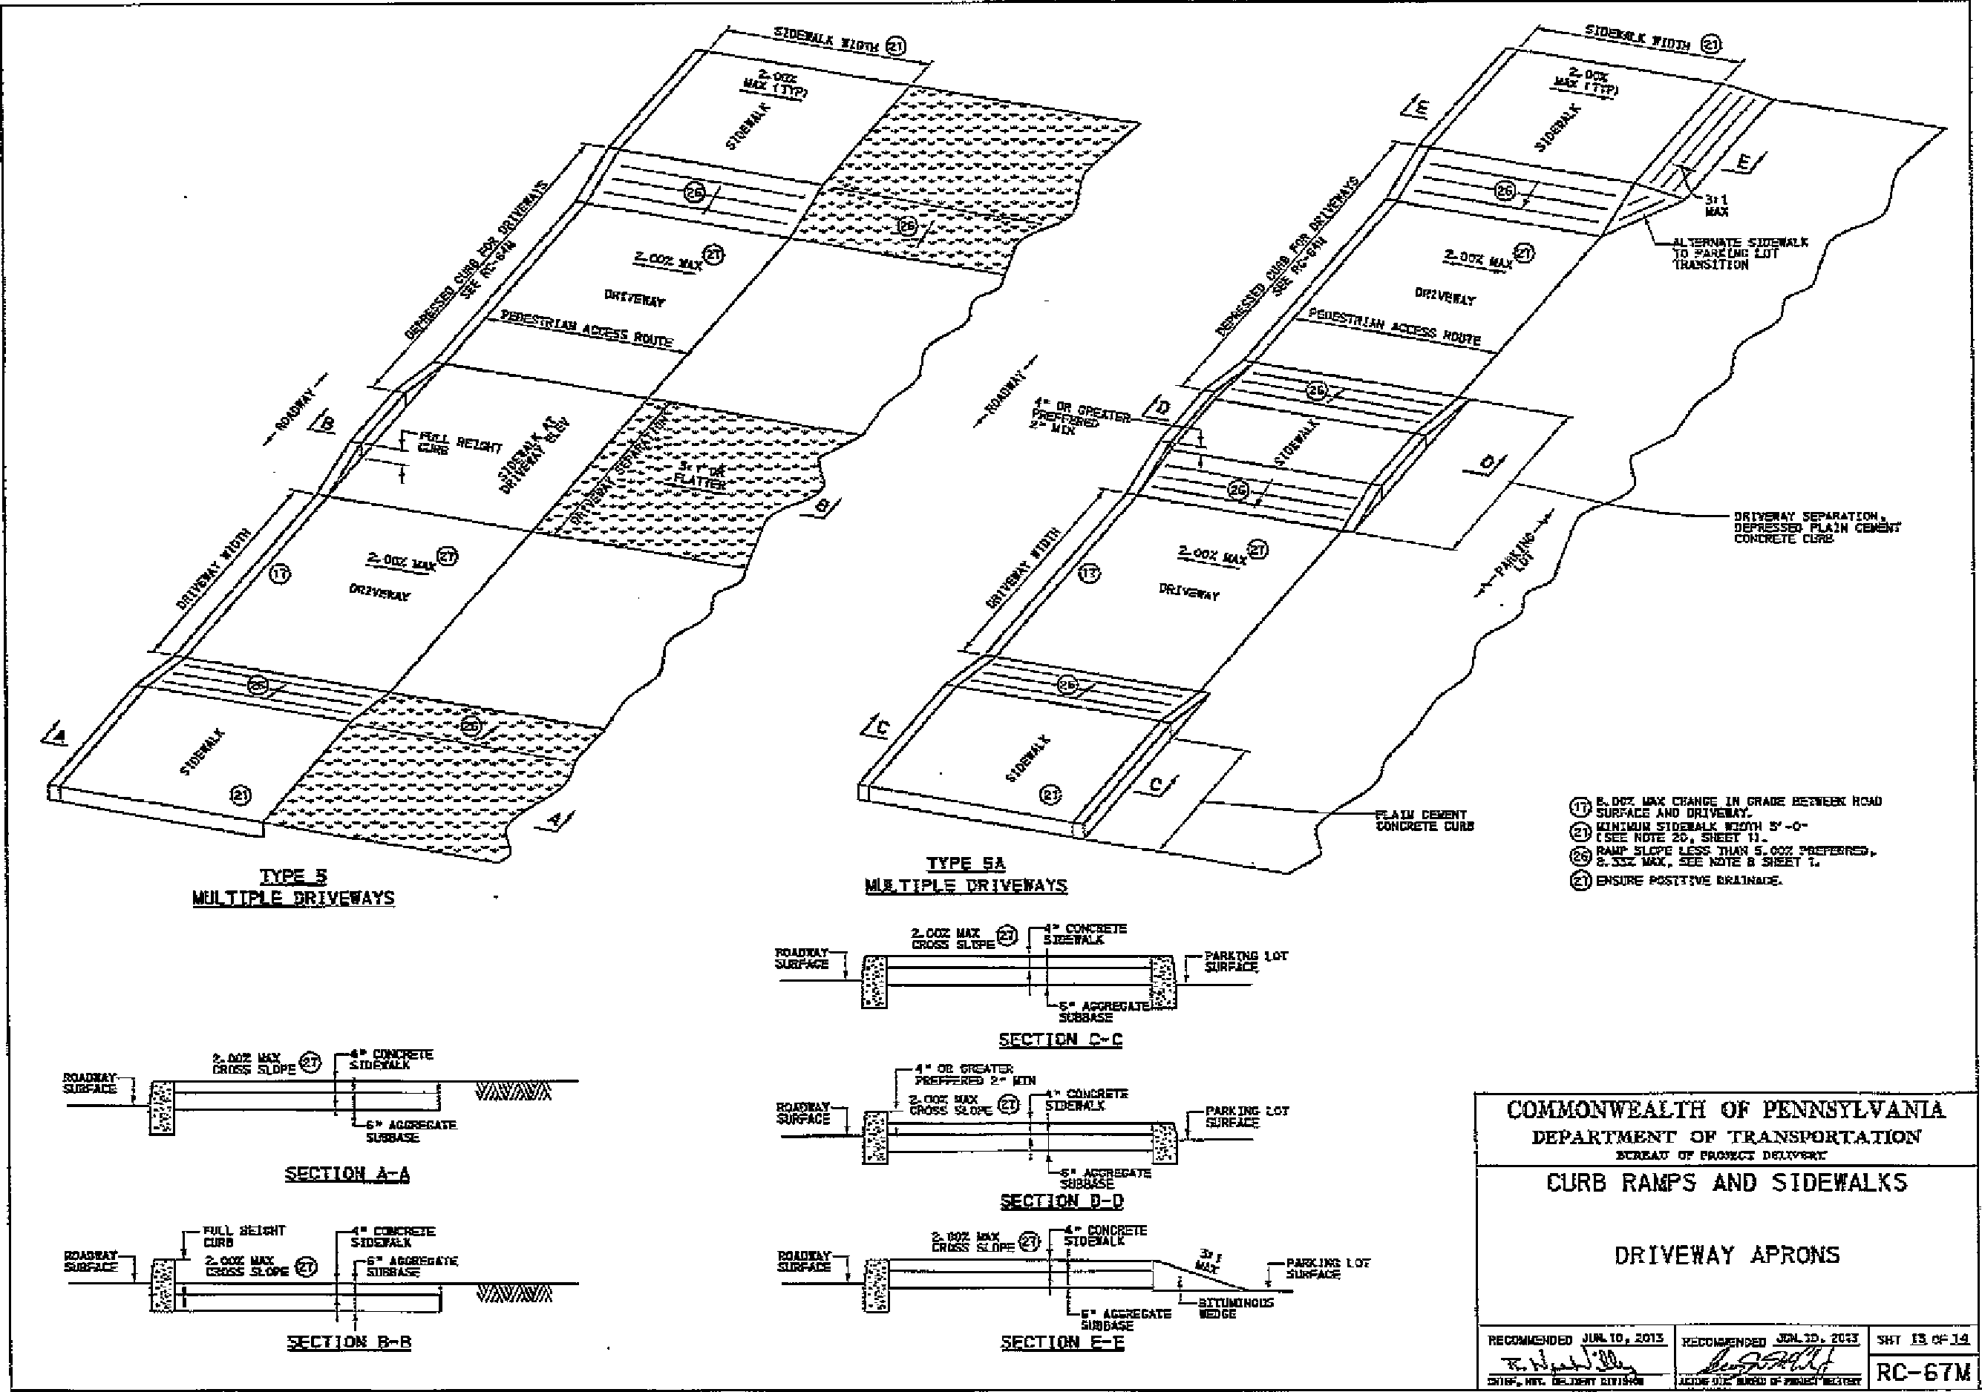
, ₊V
DRCPERAT SEPARATION. DEPRESSISt PLAIN CEREITT CONCRETE CURE
UI CIT CONCRETE CURE
1=51,
MULTIPL R WEIAYS
frA lt.DCZ 111X CHANGE IN GRADE HETIEEti HEAD SURFACE AND DRIVERAT.
ATA, MINIMUM SIDERALX MUCH 3' -0-
T.GP
TOES NOTE 20. SHEET Oh
/Q. RAPP SLOPE LESS WAN 5.022 DRUMM. AG>. &SSE VAX, SEE =RE EI SHEET L.
ENETGG POSTTGHE imaixacE.
rt.eZ.-5
MULTIPLE DR_J VEWAYS
--A• CONCSETE
SMEOLLX
t.noz ITAX
cuss SORE
ROADIGAX-i =RAZ&
VAVAVA
L. AGGREGATE
WABASH.
CONMONWEALTH OF PENNSYLVANIA
DEPARTMENT OF TRANSVORTATION
=MLA OP PROMS Demmer
SFCTI ON A-A
CURB RAMPS AND SIDEWALKS
TULL THEICHT • CCIPCREZE
CLIRD SIDEXALX
2-00X MAX..10, accarsoara
CRDSS SLOPE .021 sucara.
DRIVEWAY APRONS
_{rjr}„₄"₇.1⁻
V
sEcTinig 13-B
sill ThOIi
RECEGGIENDED MGM. TGIG
ail TN. NTT.
RC-67M
}wcprg, AILILID.RTU
117736.1OU
TRURO. DLIDPME^{T-}1
PARITNG tor
2.002 MAX felr4 cUIOXTE GROSS GLIFFE'-'
•-
AGGREG SeDBASE
SECTION ••.0
CAT GREATER
PRITTED
COVELITE
Rat1-₁ ₇₇- MORS Sams -
ru_{nx}
Ls. AccREGA-TE'^{s-}
N49⁻3 ON P-1)
0.200 _{en.} --a- CONCRETE
CMGS SLOPE 'CY FOESALIC
ROADI1AT
SLGSADE
¹—orruinNoos
E• AGGREGATE WEDGE GUODASE
SECTION E-t
le.⁰7
—PATTAIX2 LOT
51.11gChe
PARKRGG LOT SURFACE

